# **Big Mountain Skiing Resort - Summary and Recommendations**

## **Findings**

We’ve built a Machine Learning Model that predicts the price of weekend tickets for Adult Prices. Most resorts have followed a pricing model to price the tickets of weekdays and weekends similarly. So we can use the ticket price on a weekend to be our target variable.

Based on our initial discovery phase, we saw that the Vertical Drop is highly correlated with weekend ticket prices. The number of fast quads, number of total rus and total chairs seem very important too. As you can see from the plots below, there is a strong positive correlation between the variables mentioned above and ticket prices.

After the modeling phase, we found that the Snow Making area is a very important factor in determining ticket prices. This implies that people prefer guaranteed skiing! We decided to use the Random Forest Model as this model gave us the best Mean Absolute Error in ticket prices. The most important features determined are listed below:

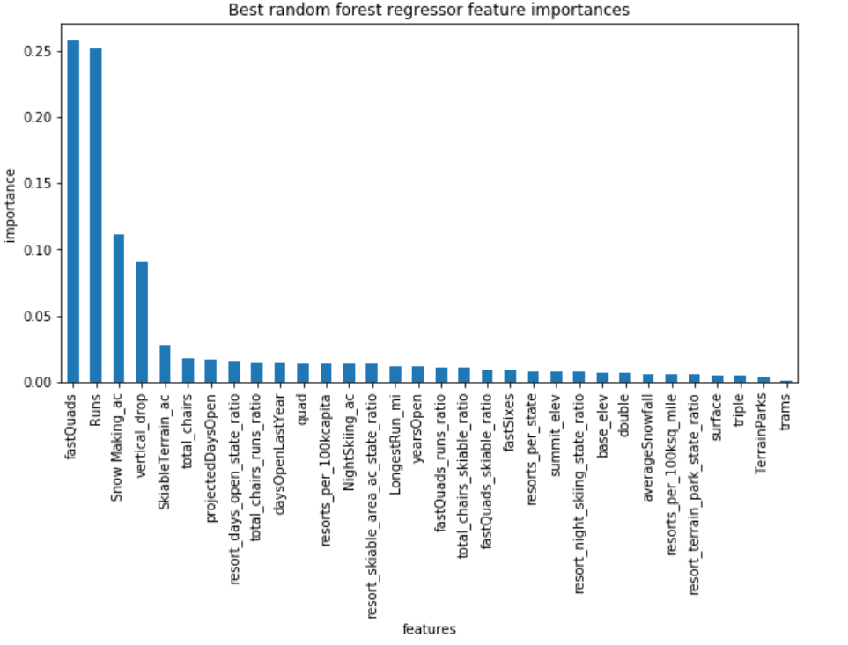

## **Recommendations:**

Our model predicts that the ticket price for the Big Mountain resort should be around $94 viz-a-viz the current price set at $81.

The margin for error in our model is around $9.5. So conservatively, you could price the tickets at $85. Optimistically, you could go as high at $90.

We based these decisions on that the fact the Big Mountain resort excels at the following with respect to its competitors:

* The resort has one of the best Vertical Drop in the segment
* The resort offers guaranteed snow making at around 625 ac, and is in the top 5 resorts
* The resort has 3 fastQuads; Most of the competition has none
* The resort excels in total chairs and total runs

## **Scenario Planning:**

Given that the resort is one of the best in the segment, we believe that the resort is under priced.

We went ahead and ran some scenarios to:

1. determine efficient cost cutting measures for the least used Runs:

*The model says closing one run makes no difference. Closing 2 and 3 successively reduces support for ticket price and so revenue. If Big Mountain closes down 3 runs, it seems they may as well close down 4 or 5 as there's no further loss in ticket price. Increasing the closures down to 6 or more leads to a large drop.*

1. Increasing the Vertical Drop

If you were to increase the Vertical Drop by 150 feet, you can charge $8.5 extra on the ticket prices. This will amount to almost $14 million in increased sales revenue assuming that there are 350,000 visitors expected every year and stay for 5 days.

What we haven’t taken into consideration is the Operating Costs and sunk costs required for this investment. If we had a clear understanding of the costs, we could have recommended whether the invest yields a positive ROI.